Insert your name, centre number and candidate number into the header above.
Save this evidence document as evidence_ followed by your centre number_ candidate number. For example: evidence_ zz999_9999
Screenshots or program listings must be copied into appropriate cells in the following tables.
Examiners must be able to read the contents including any screenshots without the use of a magnifying glass. Answers that are not readable or missing will not be awarded any marks.
Save this evidence document at regular intervals, for example, every 10 minutes.
Question 1
Part 1(a)
class node:
def __init__(self, data, next_node):
self.data = data
self.nextNode = next_node

Part 1(b)
startPointer = 0
emptyList = 5
linkedList = [
node(1, 1),
node(5, 4),
node(6, 7),
node(7, -1),
node(2, 2),
node(0, 6),
node(0, 8),
node(56, 3),
node(0, 9),
node(0, -1),
]

Part 1(c)(i)
def outputNodes(linkedList, startPointer):
print(f"Outputting Nodes from {startPointer}")
while startPointer != -1:
print(linkedList[startPointer].data)
startPointer = linkedList[startPointer].nextNode

Part 1(c)(ii)
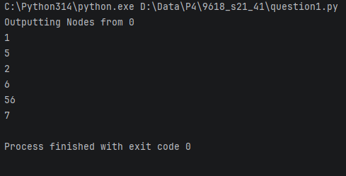

Part 1(d)(i)
def addNode(linkedList, startPointer, emptyList):
success = False
data = int(input("Enter data to add: "))
# Getting end of the list:
while startPointer != -1:
prevPointer = startPointer
startPointer = linkedList[startPointer].nextNode
while linkedList[emptyList].nextNode != -1:
# New Node:
linkedList[emptyList].data = data
linkedList[emptyList].nextNode = -1
# updating to join th new Node in linked list
linkedList[prevPointer].nextNode = emptyList
# Empty List updating
emptyList = linkedList[emptyList].nextNode
success = True
# Return true if inserted successfully
return success
# List is full as no space in emptyList
return success

Part 1(d)(ii)
def main():
outputNodes(linkedList, startPointer)
if addNode(linkedList, startPointer, emptyList):
print("Successfully added node")
else:
print("No space left to add node")
outputNodes(linkedList, startPointer)

Part 1(d)(iii)
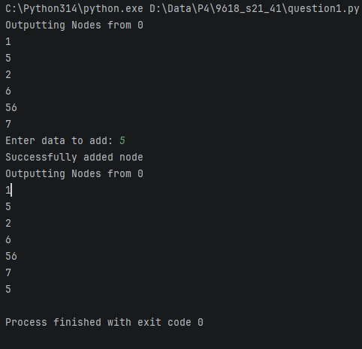

Question 2
Part 2(a)
arrayData = [10, 5, 6, 7, 1, 12, 13, 15, 21, 8]

Part 2(b)(i)
def linearSearch(search):
global arrayData
found = False
size = len(arrayData) - 1
for i in range(size):
if arrayData[i] == search:
found = True
# If not found, returns False
return found

Part 2(b)(ii)
def main():
search = int(input("Enter a number to search: "))
if linearSearch(search):
print(f"{search} is present in the list")
else:
print(f"{search} is not present in the list")

Part 2(b)(iii)
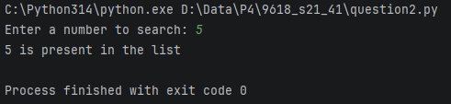

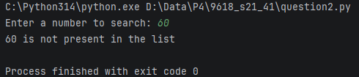

Part 2(c)
def bubbleSort():
global arrayData
size = len(arrayData)
for x in range(size):
for y in range(0, size):
if arrayData[y] > arrayData[y + 1]:
# swapping
temp = arrayData[y]
arrayData[y] = arrayData[y + 1]
arrayData[y + 1] = temp

Question 3
Part 3(a)
class TreasureChest:
def __init__(self, q, ans, points):
self.__question = q # String
self.__answer = ans # Integer
self.__points = points # Integer

Part 3(b)
{Copy and paste program code listing for question 3(b) here}

Part 3(c)(i)
{Copy and paste program code listing for question 3(c)(i) here}

Part 3(c)(ii)
{Copy and paste program code listing for question 3(c)(ii) here}

Part 3(c)(iii)
{Copy and paste program code listing for question 3(c)(iii) here}

Part 3(c)(iv)
{Copy and paste program code listing for question 3(c)(iv) here}

Part 3(c)(v)
{Copy and paste screenshots of the two tests for question 3(c)(v) here}

